**Jesus Medina**

**CS – 521**

**Instructions for Running Final Project**

**Auto Sales Inventory/ Sales Tracker**

* When you run the program, you will see the main menu screen as noted below:

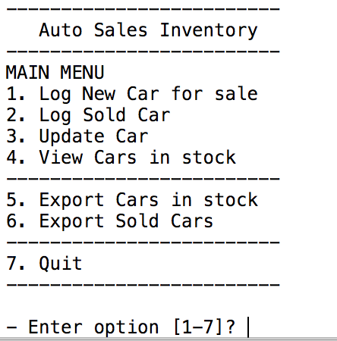

* The car_inventory.txt file is an example of data that already contains a list of cars that are currently in the business owner’s database by default.
* When the user starts the program, the program will read contents of the car_invenory.txt file (example below) and import its information into the database. I was able to manipulate the program to get the respective fields from the txt file and store it as values into the database for each respective car.

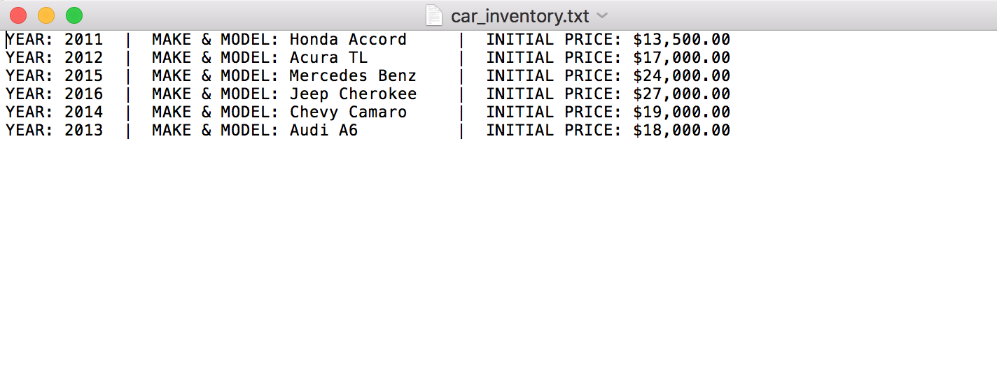

* At program start, user may start by selecting option 4 to see data of the .txt file, which contains details of cars that are already in stock and available to sell.

(OPTIONAL)

**Example:**

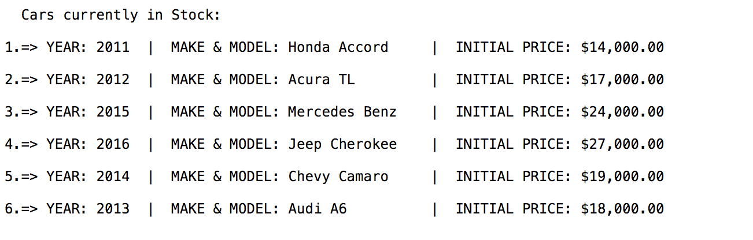

Or the user may go right ahead and start from option 1 or 2, to either log a new car into the in stock inventory or mark a car as sold.

* From the main menu screen, each option notes as following:

1. **Option 1** - Allows the user to log a new car with its details (Year, Make & Model, and initial price) to the existing database. As the user adds new cars into the program, the program will then add each car to this existing database as well as into the car_inventory.txt file.

**Example:**

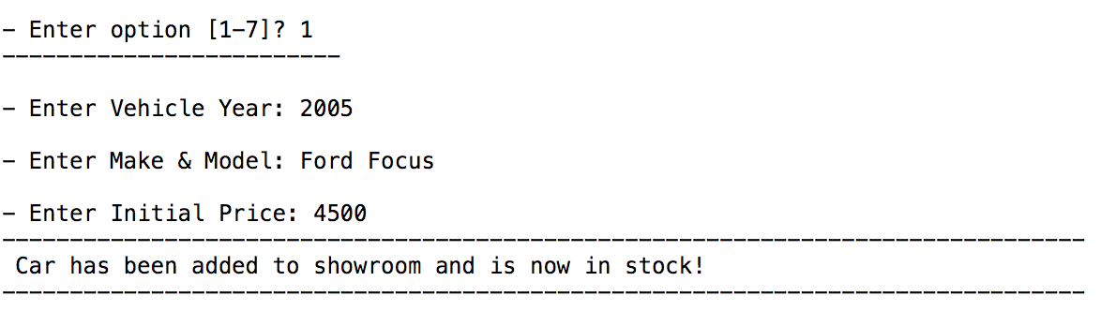

1. **Option 2** - Allows the user to see cars currently in stock and then gives the user the ability to pick a car from the database to log it as sold. This will then remove the car from current cars in stock and into a sold cars list.

If you then select **option 4** (View Cars in Stock) on the main menu afterward, the car will not show in the lot.

**Example:**

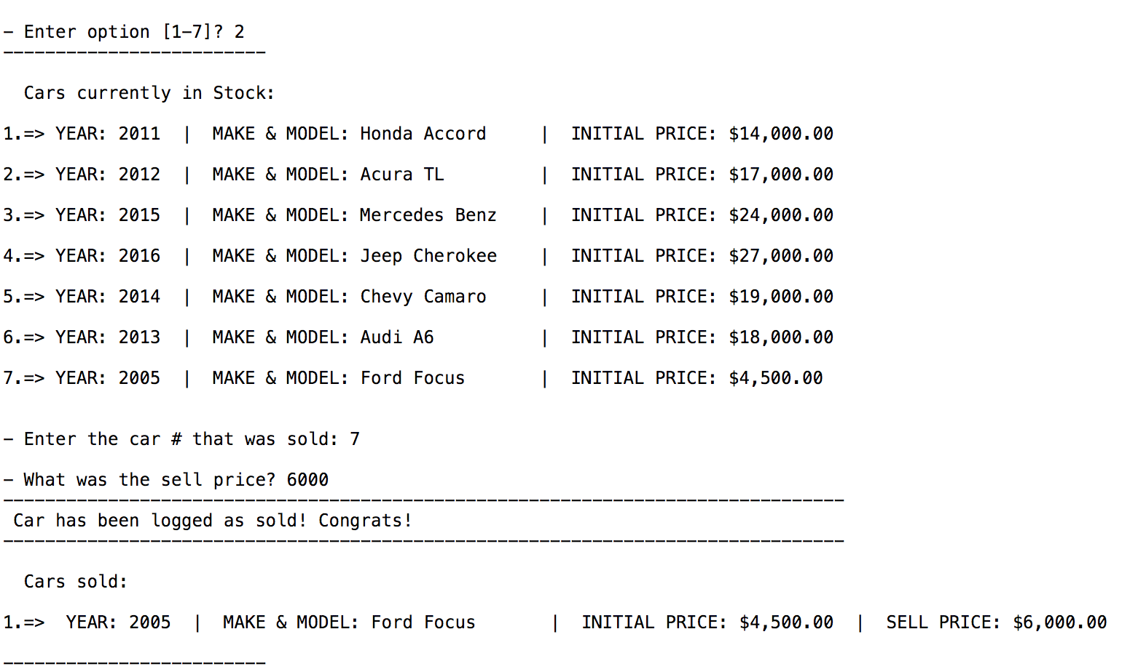

1. **Option 3** - Allows the user to update/edit a car in the database. They can edit/update a specific attribute such as car year, make & model, or initial price of any selected car.

**Example:**

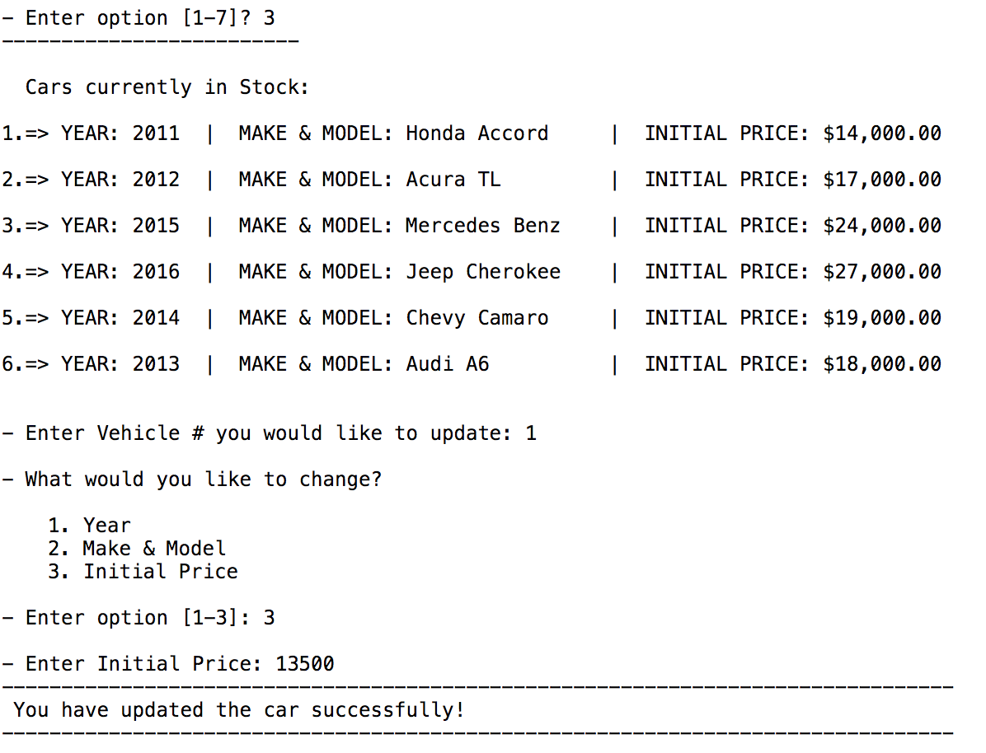

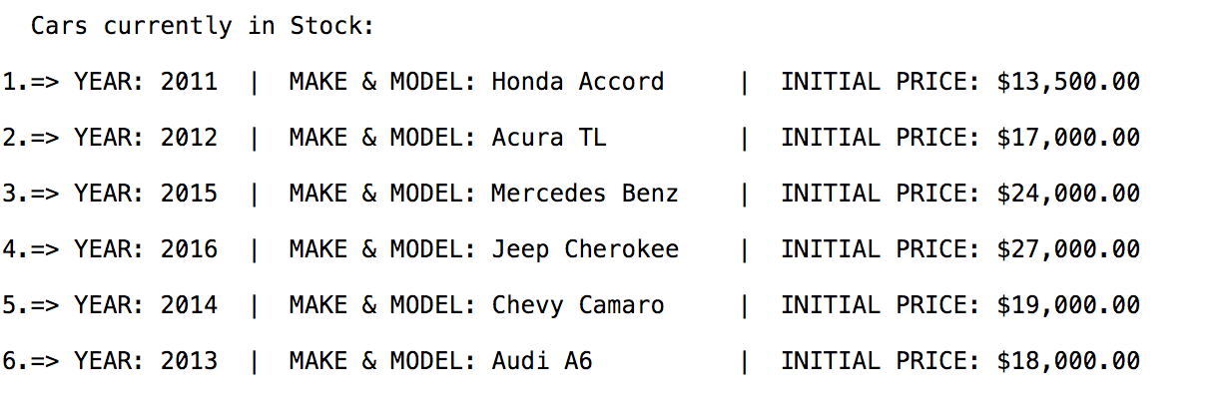

1. **Option 4** - Allows the user to view all the cars currently in stock.

**Example:**

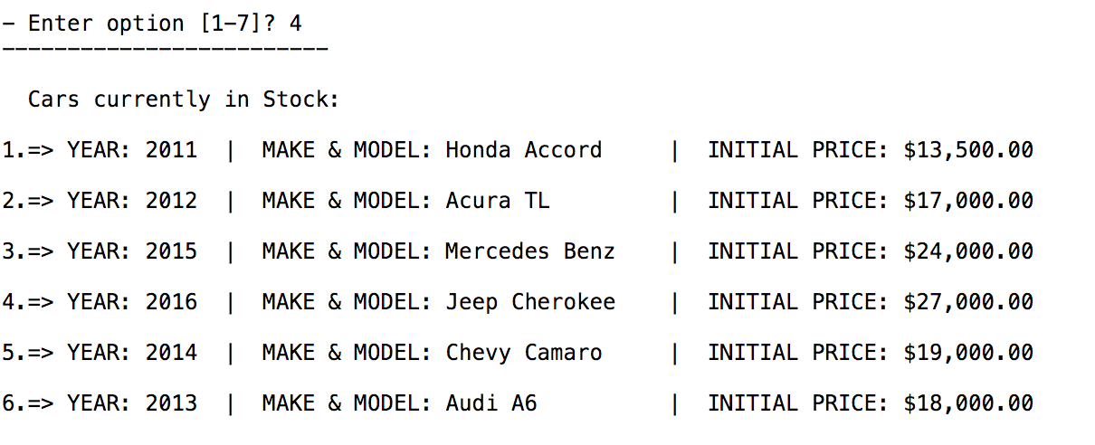

1. **Option 5** - Allows the user to export a list of all the current Cars currently in stock to a txt file to view all the cars currently in stock. As the user adds new cars into the program, the program will then add each car to this existing log.

**Example:**

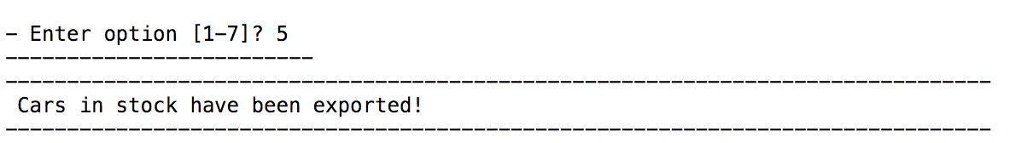

* + **Then user will then check txt file. Example of export below:**



1. **Option 6** - Allows the user to export a list of all the Cars that have been sold to a txt file to view all the cars sold. He/she can then compare initial price to sell price.

**Example:**

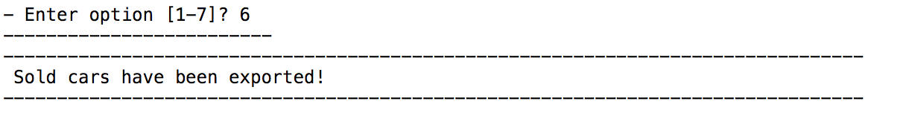

* + **Then user will then check txt file. Example of export below:**

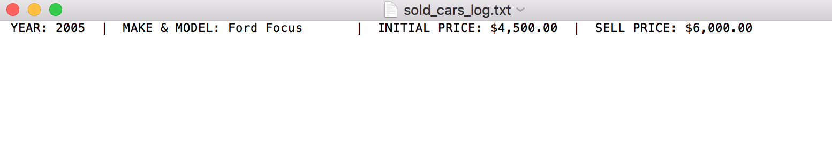

1. **Option 7** - Allows the user to exit the program.

**Example:**

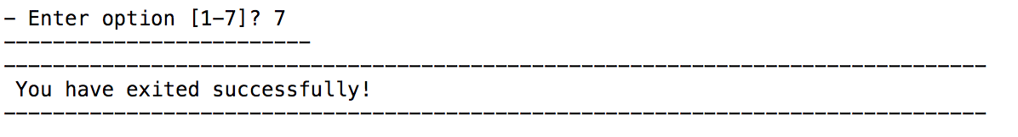

**Notes:**

* If user enters an option not in range on the main menu, the program will prompt user that it was an invalid option and ask for option selection again. If they also enter in any text, it will prompt user they did not enter a # option and will ask for option selection again.

**Example:**

